REQUIREMENT ANALYSIS PHASE

Customer Journey Map

Project Title

Optimization of Users, Groups, Roles with Access Control and Workflows in ServiceNow

Objective

The Customer Journey Map illustrates the interaction of a system administrator or end user with the ServiceNow application from requesting access to receiving the required permissions.

Customer Journey

Stage| User Activity| System Response| User Experience
Login| User logs into ServiceNow| Authentication is verified| Secure login
Access Request| User requests a role or access| Request is submitted| Simple and convenient
Approval| Manager/Admin reviews request| Workflow triggers approval| Faster approval
Role Assignment| Approved role is assigned| User receives required access| Secure authorization
Access Verification| User accesses assigned modules| ACL validates permissions| Controlled access
Notifications| User receives email notification| Workflow sends notification| Improved communication

Benefits

- Reduced manual work.
- Faster approval process.
- Secure access management.
- Better user experience.
- Improved transparency.

Conclusion

The Customer Journey Map demonstrates how the proposed solution simplifies user access management while maintaining security and efficiency.

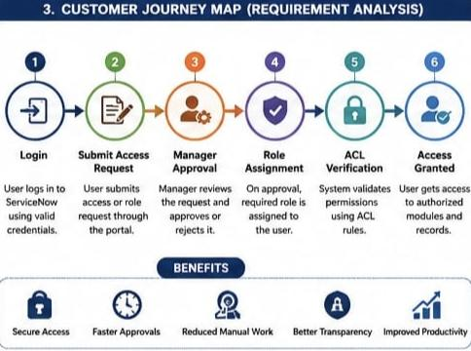

Data Flow Diagrams and User Stories

Data Flow Diagram (Level-0)

The proposed system consists of the following flow:

User → Access Request → ServiceNow System → Admin Approval → Role Assignment → ACL Verification → User Access

Data Flow Description

1. User submits an access request.
2. ServiceNow stores the request.
3. Workflow sends the request for approval.
4. Administrator reviews and approves/rejects.
5. System assigns the required role.
6. ACL verifies access permissions.
7. User gains authorized access.

User Stories

User Story 1

As a System Administrator, I want to create users so that employee information is managed efficiently.

User Story 2

As an Administrator, I want to create groups to organize users based on departments.

User Story 3

As an Administrator, I want to assign roles so users can access only authorized modules.

User Story 4

As a Manager, I want access requests to be approved automatically through workflows.

User Story 5

As a User, I want secure access based on my assigned role.

Conclusion

The Data Flow Diagram and User Stories describe the functional behavior of the proposed ServiceNow solution.

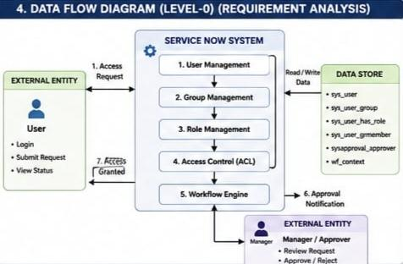

Solution Requirements

Functional Requirements

- Create users.
- Create groups.
- Assign users to groups.
- Create roles.
- Assign roles to users.
- Configure ACLs.
- Automate approvals using Flow Designer.
- Send notifications.
- Maintain audit records.

Non-Functional Requirements

- Security
- Reliability
- Performance
- Scalability
- Availability
- Maintainability
- Usability

Business Requirements

- Reduce manual administration.
- Improve organizational security.
- Automate approval process.
- Ensure compliance.
- Centralize access management.

Expected Outcome

The solution provides secure, automated, and efficient identity and access management using ServiceNow.

Technology Stack

Front-End

- ServiceNow Forms
- Service Portal (if applicable)
- UI Builder (if applicable)

Back-End

- ServiceNow Platform
- Glide System
- Business Rules
- Script Includes

Database

- ServiceNow Tables
- sys_user
- sys_user_group
- sys_user_has_role
- sys_user_grmember

Security

- Access Control Lists (ACLs)
- Role-Based Access Control (RBAC)

Workflow & Automation

- Flow Designer
- Notifications
- Approval Engine

Development Tools

- ServiceNow Personal Developer Instance (PDI)
- Studio
- Flow Designer

Conclusion

The ServiceNow platform provides all the required tools for implementing secure user, group, role, ACL, and workflow management within a single integrated environment.

